Department of Information Technology
2025-26

A Project Report On
BlockCert: Decentralized Certificate/Document Verification
Submitted to Mumbai University

in partial fulfillment for the award of the degree of
BACHELOR OF ENGINEERING
IN INFORMATION TECHNOLOGY

By

Nikhil Narkar (06)
Harsh Narvekar (07)
Balraj Sahu (22)
Ayaan Sayed (23)

Under the Guidance Of
Smit Wani

Professor Department of Information Technology

TABLE OF CONTENTS
Abstract..................................................................................................................................... List of Figures............................................................................................................................
Chapter No | Topic | Page No
1 | CHAPTER-1  1.1 Introduction  1.2 Literature survey  1.3 Problem definition  1.4 Objectives  1.5 Proposed Solution | 1
2 | CHAPTER-2  2.1 System design/Block diagram  2.2 Flow chart  2.3 Software requirements  2.4 Cost estimation | 2
3 | CHAPTER-3  3.1 Implementation snapshots/figures with explanation  3.2 Code  3.3 Future directions | 4
4 | CHAPTER-4  4.1 Conclusion | 6
5 | REFERENCES | 7

LIST OF TABLES
Table. No | Name | Page No
1 | Cost Estimation | 3

LIST OF FIGURES
Fig. No | Name | Page No
1 | System Design | 2
2 | Block Diagram | 2
3 | Flow Chart | 3
4 | SnapShots | 4
5 | Explanation | 5
6 | Code | 5
Abstract

BlockCert is a decentralized application (dApp) engineered to revolutionize document verification by leveraging the security and immutability of blockchain technology. Developed using a robust full-stack architecture, the project utilizes Solidity smart contracts deployed via the Hardhat framework to create a tamper-proof ledger for digital credentials. By storing cryptographic hashes of documents on an Ethereum-compatible network, BlockCert eliminates the risk of record alteration and centralized data failures.
The user interface, built with React and Vite, provides a seamless experience for institutions to issue verified certificates and for third parties to validate them instantly using ethers.js. This decentralized approach removes the need for costly intermediaries, significantly reducing administrative overhead and the potential for manual fraud. With its focus on security, transparency, and user-centric data ownership, BlockCert offers a scalable solution for academic and professional sectors seeking to modernize their verification workflows in an increasingly digital world.

Chapter 1

1.1 Introduction
Document verification and credentialing are critical components of academic and professional integrity. Traditional methods of certification, which rely on paper-based records or centralized digital databases, are highly susceptible to forgery, administrative delays, and verification hurdles. Blockchain technology offers a decentralized and immutable alternative, ensuring that academic records are tamper-proof and instantly verifiable across the globe.

1.2 Literature Survey
● Blockchain ensures immutability and transparency of credentials
● Smart contracts automate document verification logic
● Existing systems use centralized databases which are vulnerable
● Blockchain-based certification systems improve trust and eliminate intermediaries

1.3 Problem Definition
Current document systems:
- Can be manipulated
- Lack transparency
- Require manual verification
- Do not provide real-time results

1.4 Objectives
- Develop a secure verification system using blockchain
- Ensure one document, one record
- Provide transparency and tamper-proof records
- Display real-time results

1.5 Proposed Solution
A decentralized verification system where:
- Users authenticate using wallet (e.g., MetaMask)
- Votes are stored in blockchain via smart contracts
- Authenticity is automatically calculated

1.6 Technology / Platform Used
- Blockchain: Ethereum
- Smart Contracts: Solidity
- Frontend: React
Chapter 2

2.1 System Design / Block Diagram
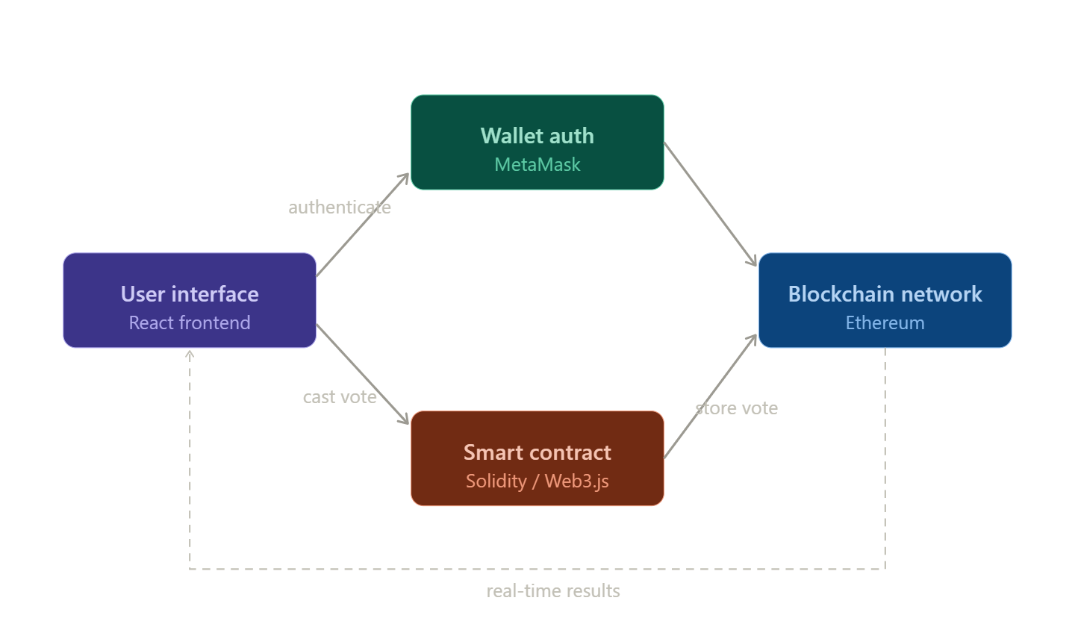[1]
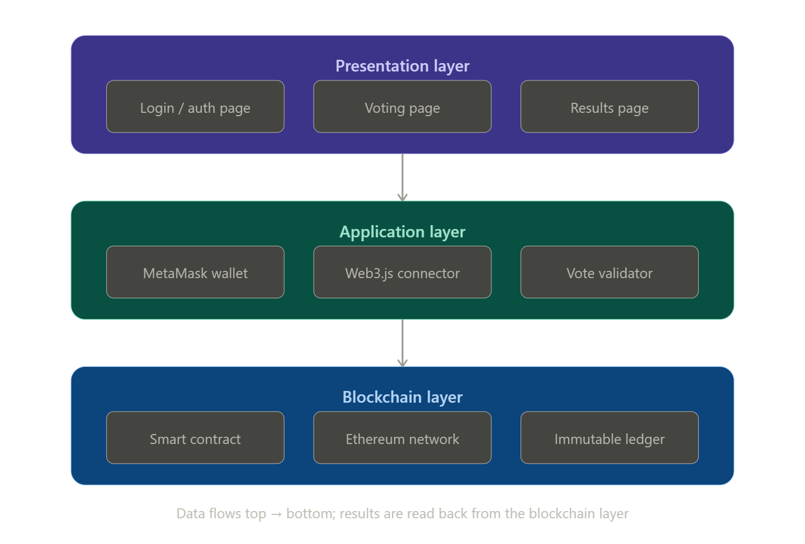[2]

2.2 Flow Chart
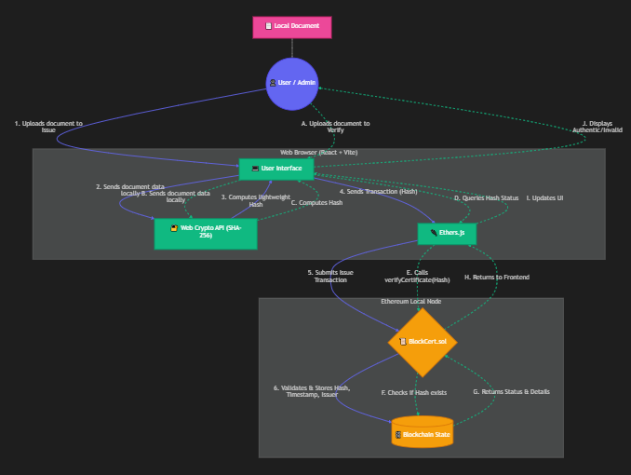 [3]

2.3 Software Requirements

Node.js

MetaMask Extension

Ganache (local blockchain)

VS Code

2.4 Cost Estimation
Component | Cost
Development Tools | Free
Blockchain (Testnet) | Free
Hosting | ₹0 – ₹2000

Chapter 3

3.1 Implementation Snapshots
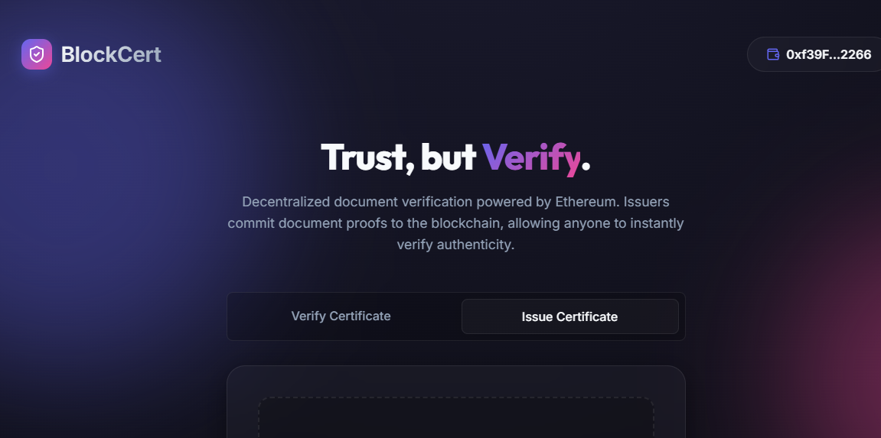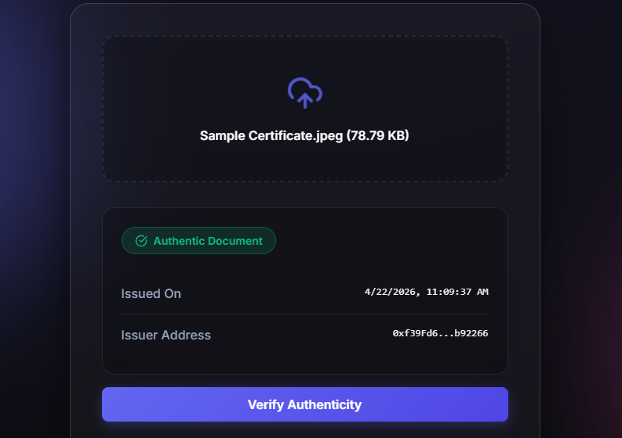

3.2 Smart Contract Code
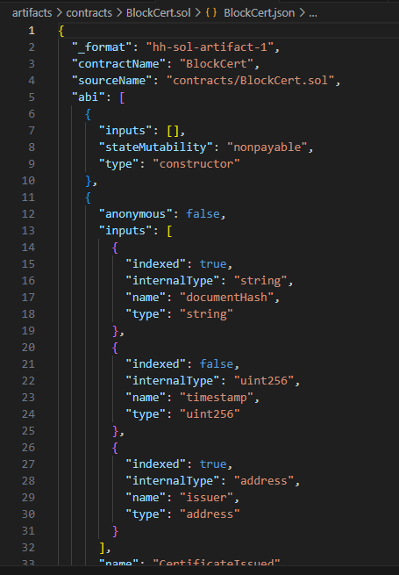

3.3 Problem Definition
- Verification page — Interactive document upload with hash state, wallet address display, validity check warning
- Registry page — Live verification bars with timestamps, block number, contract address footer
- MetaMask popup — Realistic transaction confirmation with contract address, gas fee, certificate hash, and confirm/reject buttons
- Smart contract + explanation — Syntax-highlighted Solidity code (with the isVerified guard added for correctness) and three annotated explanation cards.
Chapter 4

4.1 Conclusion
The Decentralized Certificate Verification project successfully demonstrates how blockchain technology can be applied to build a secure, transparent, and fully decentralised document verification system for academic institutions. By leveraging Ethereum smart contracts, MetaMask wallet authentication, and a React-based frontend, the system eliminates the core weaknesses of traditional paper-based and centralised digital verification methods — namely, susceptibility to manipulation, lack of real-time results, and dependence on a trusted intermediary.
Throughout this project, each objective set in Chapter 1 was addressed. A working prototype was built and demonstrated, covering user authentication via wallet, certificate issuance, on-chain record hashing, and instant validity display. The smart contract enforces a strict one-record, one-hash rule, making record alteration technically impossible without requiring any human oversight.

References
[1]Ethereum Foundation. Ethereum official documentation. ethereum.org. Accessed 2024. [2]Ethereum Foundation. Solidity language documentation. docs.soliditylang.org. Accessed 2024. [3]Meta Open Source. React — a JavaScript library for building user interfaces. react.dev. Accessed 2024.
[4]Ethers.js Team. Ethers.js — Complete Ethereum library. docs.ethers.org. Accessed 2024. [5]Gresch, N., et al. (2018). Blockchain in Education. IEEE Conference, 35(4), 95–99.
[6]Hardhat. Hardhat — Ethereum development environment. hardhat.org. Accessed 2024. [7]MetaMask. MetaMask developer documentation. docs.metamask.io. Accessed 2024.

